Garage management System

Thiruvalluvar college of engineering technology

**Presented by** :

M.Yuvasri( NM ID : 7F948C085B3BD48AA4C4B6E7F2F64F9E)

S. Pandiyan ( NM ID : 5A3DF11C0D0061EB5E74D4B495716C14)

M.Rajesh(NM ID : AD9BB5853711CC0A95445482A7B19978)

**Project title : Garage Management System**

**Overview :**

**Salesforce, a leading customer relationship management (CRM) platform, can be tailored to manage garage operations efficiently. A *Garage Management System (GMS)* built on Salesforce integrates core functionalities to handle day-to-day operations of vehicle service centers, repair shops, and garages.**

**Objectives:**

**1. Operational Efficiency**

Automate appointment scheduling, work order management, and inventory tracking to reduce manual intervention.

Optimize resource allocation, such as mechanics, spare parts, and equipment.

Minimize service delays through real-time task monitorin

**2. Enhanced Customer Experience**

Deliver a personalized customer journey by maintaining detailed profiles, service history, and vehicle records.

Provide self-service portals for appointment booking, service tracking, and invoice payments.

Send timely reminders for vehicle maintenance, warranty expiration, and promotions.

**3. Centralized Management**- Offer a single platform to manage multiple garage locations and streamline operations.

Maintain consistent processes and data across all branches.

Enable decision-makers to monitor performance and revenue through dashboards and reports.

**4. Cost Management**

Monitor inventory levels to avoid overstocking or stockouts.

Automate procurement of spare parts based on demand forecasting.

Track labor costs and optimize job assignments to reduce downtime

**5. Data-Driven Decision Making**

Use analytics and reporting tools to gain insights into garage performance, revenue, and customer trends.

Predict demand for services and parts using historical data.

Identify opportunities for cost reduction and process improvement

**6. Integration and Scalability**

Seamlessly integrate with third-party tools for accounting, payment processing, and vehicle diagnostics.

Scale the system to accommodate business growth, such as new locations or expanded services.

Support integrations with IoT for real-time vehicle condition monitoring

**7. Regulatory Compliance**

Maintain accurate records of services, parts usage, and billing for audits and compliance requirements.

Ensure customer data is handled securely to comply with privacy regulations

**8. Revenue Growth**

Increase upselling and cross-selling opportunities by analyzing customer preferences and service history.

Build customer loyalty through targeted promotions, rewards, and consistent service quality.

**Salseforce Key Features:**

**1. Customer Relationship Management**

Maintain detailed customer profiles with service history, contact information, and vehicle details.

Automated reminders for periodic maintenance, warranty expiration, or upcoming appointments**.**

**2. Appointment Scheduling**

Calendar integration for real-time scheduling of vehicle servicing and repair jobs.

Appointment confirmation and rescheduling via email or SMS notifications.

**3. Inventory Management**

Track spare parts availability in real-time.

Automate stock reordering when inventory falls below threshold levels.

Integration with suppliers for seamless parts procurement.

**4. Work Order Management**

Generate and track work orders for each job, assigning them to mechanics.

Monitor job progress and completion in real-time.

**Sales to solution design**

1. **Creating developer org in salesforce**: Enter details for sign up in salesforce

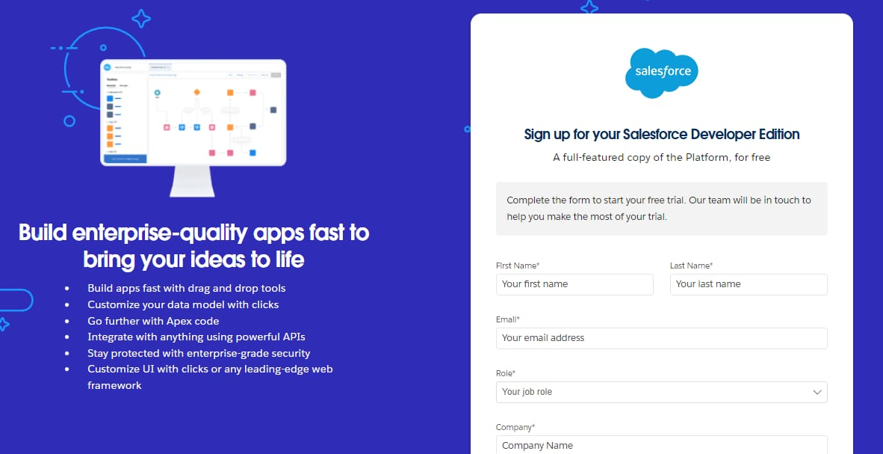  
2) Account activation : Go to the inbox of the email that you used while signing up.click on

the verify account to activate your account .

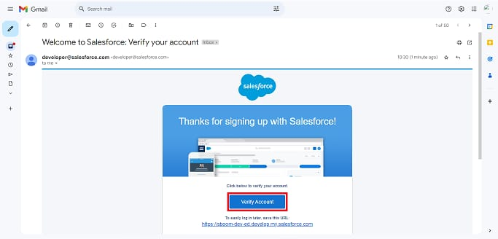

3 ) you will get the set up page after verify your account in salesforce sign in

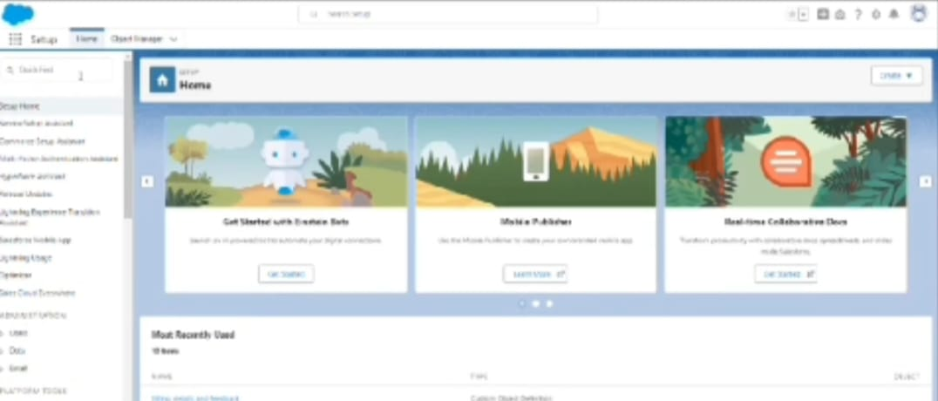

4) creation of currency field on appointment object

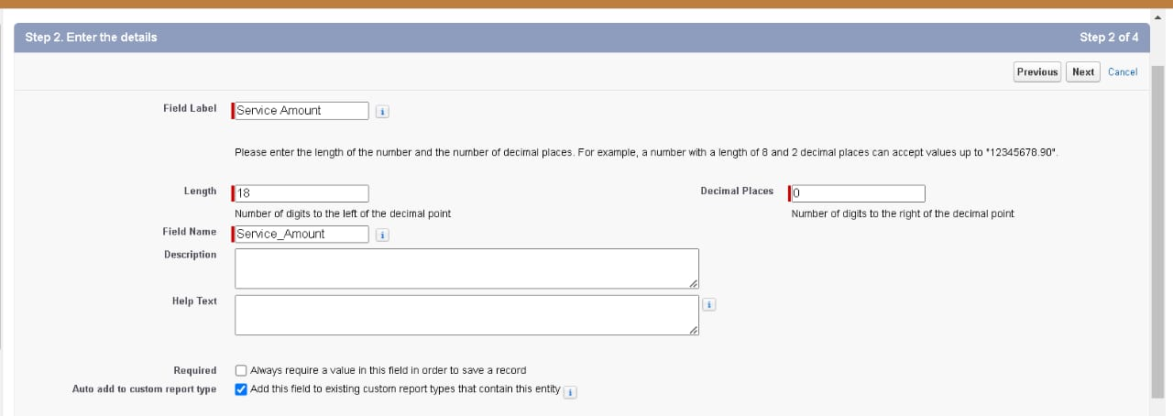

5) click on next, creation of text field

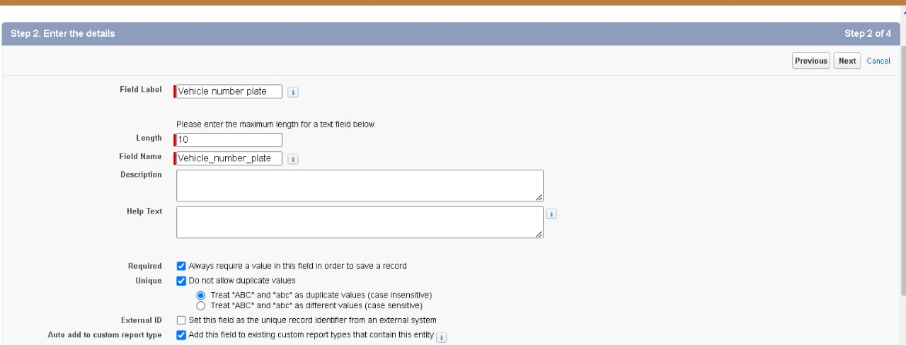

**Benefits:**

**1. Improved Efficiency & Streamlined Operations**

Automated Workflows: GMS automates tasks such as appointment scheduling, invoicing, and inventory management, reducing the need for manual input and minimizing errors.

Task Management: Assigning tasks to technicians and tracking their progress in real time ensures that work is organized, prioritized, and completed on time.

Faster Service Turnaround: With integrated systems for parts ordering, work orders, and customer communication, technicians can work more efficiently, resulting in quicker service delivery.

**2. Enhanced Customer Experience**

Quick Access to Customer History: A GMS stores detailed records of customer interactions, past services, and vehicle histories, allowing staff to provide personalized service.

Appointment Scheduling: Customers can easily book appointments online or via an app, with real-time availability and reminders, reducing the chances of missed or double-booked appointments.

Transparency & Communication: Automated notifications for updates on service status, approval requests, and invoicing keep customers informed and engaged throughout the process.

**3. Better Inventory Management**

Real-Time Stock Tracking: A GMS allows for real-time tracking of parts and supplies, helping to avoid stockouts or overstocking. This ensures that the garage always has the necessary parts on hand when required.

Automated Reordering: When stock levels fall below a predefined threshold, the system can trigger automatic reordering of parts, preventing delays in service and maintaining operational continuity.

Cost Control: By managing inventory more efficiently, garages can reduce wastage, avoid over-ordering, and ensure more accurate costing for repairs and services.

**4. Improved Financial Management**

Accurate Invoicing: GMS automates the invoicing process, ensuring accuracy and reducing the risk of errors in billing. It can also integrate with accounting software for seamless financial management.

Tracking Revenue & Expenses: The system allows for easy tracking of revenue, expenses, and profit margins, providing valuable insights into the financial health of the business.

Payment Integration: Customers can pay via integrated payment gateways, allowing for easy tracking of payments and reducing payment delays.

**5. Data-Driven Insights**

Comprehensive Reporting: A GMS provides detailed reports on various aspects of the business, such as service performance, technician productivity, customer satisfaction, and financial metrics.

Actionable Analytics: By analyzing data on customer preferences, service history, and inventory, garages can make informed decisions on marketing, resource allocation, and business strategy.

Performance Tracking: Track the performance of technicians, service advisors, and other

**Conclusion:**

Garage Management System (GMS) plays a crucial role in streamlining operations, improving efficiency, and enhancing customer satisfaction for garage businesses. By automating tasks such as inventory management, service tracking, appointment scheduling, and invoicing, a GMS reduces manual errors, optimizes resource allocation, and ensures smooth day-to-day operations. Additionally, it provides valuable insights into business performance, helping garage owners make data-driven decisions to grow their businesses. Ultimately, adopting a GMS contributes to improved service quality, cost savings, and increased profitability, making it an essential tool for modern garage management.